**Manual for ZY_FP_Analysis_JHU.mlappnstall**

***Overview:***

This application was developed to analyzes fiber photometry (FP, from Neurophotometrics system) data and aligns it with the forced swim test behavioral data processed in Bonsai-RX, with a user-friendly GUI. The user does not need to have coding experience.

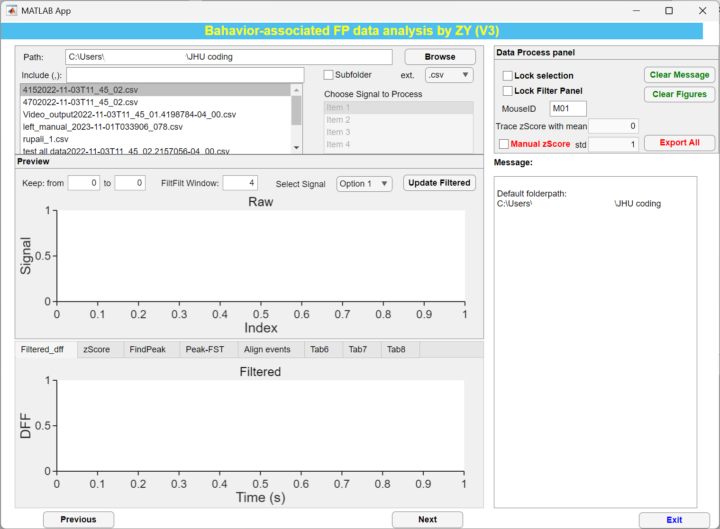

**Select the FP file:**

Use **Browser** to locate the file folder, then choose the FP data (.csv) recorded via the Neurophotometrics FP system.

**Preview Window**

Once the proper data has been selected, the raw FP data will populate the “Preview” window. Here, users can 1) crop photometry data to analyze windows of interest; 2) filter the signal with a zero-phase filter (filtfilt, default filter window = 4 as even number, 0 means no filter applied); 3) select which signal to analyze; 4) click “**Update Filtered**” button to update the final dF/F signal used for subsequent analyses.

Note: After selecting the signal, user can name the **MouseID** (e.g., M01_H_S1) for the data exportation.

**Filtered dF/F Window**

This window displays the final dF/F signal, which will be z-scored and used to align FP data to FST data. Please click the “**Update Filtered**” to update the view if you changed any parameters in Preview Window.

**zScore Window**

Select the proper FST behavior file (if any) to analyze. This will populate the table on the left with the time, code, and class data. Now check the “**Include FST**” button to synchronize FST and FP recordings in the table on the right:

1. **Time** (the start time of the immobility or mobility bout)
2. **Code** (the name of the behavior (immobility or mobility, etc.))
3. **Class** (the number associated with the behavior)
4. **Duration** (the time, in seconds, of the immobility or mobility bout)
5. **Time_s** (the time, in seconds, where the immobility or mobility bout starts in the photometry data. It is the closest timestamp in the FP data compared to the video timestamps)
6. **Index** (the index in the FP data where the immobility or the mobility bout starts)

Furthermore, after marking the checkbox, two more plots will appear. The first plot is the cropped, filtered, and z-scored dF/F FP data with manual immobility bouts overlaid. Clicking the “Plot” button will always re-plot the figures with new settings.

**Peak Find (Habituation) Window**

The following window asks the user for parameters related to peak finding analysis. The parameters entered in this window will be applied to both the peak finding along the whole trace, as well as the statistics during the “Habituation” period.

The parameters that the user can modify are as follows:

1. **Habituation ends (min):** This is how long the habituation period lasts. The prefilled standard is 2 minutes.
   1. The starting time point for habituation is always the point where you cropped from the beginning. For example, if you cropped at 4800 frames, we can calculate the starting point in minutes. We take 4800 frames, divide by 20 frames per second (your effective recording frame rate), and get 240 seconds. So, our starting point for habituation is 240 seconds (or 4 minutes). Since our input time is 2 minutes, we would choose a habituation period starting at 4 minutes and ending at 6 minutes for a total of 2 minutes.
2. **Minimum Peak Prominence:** This value sets a minimum threshold for which peaks are authentic and which to count as noise. The *prominence* of a peak measures how much the peak stands out due to its intrinsic height and location relative to other peaks. Larger values will require more prominent peaks to be counted as accurate, and lower values will require less prominent peaks to be counted as valid. FP signals will inherently differ between subjects due to many factors like surgical success, viral expression, probe location, etc. Therefore, the same value shouldn’t be used for all animals. The goal should be to input a value that maximizes the finding of true peaks (see examples of peak waveforms in the literature to cross-reference with your peaks) and minimizes the finding of noise or false peaks.
3. **Bin Size (Seconds):** This value will be used during peak frequency calculations. The standard value is set at 20 seconds.

Clicking the “FindPeak” button will fill the “Peak Finding Data” table, which contains the following columns:

1. **Time_s** (The time in seconds where the peak occurred, including the cropped period)
2. **Time_m** (The time in minutes where the peak occurred, including the cropped period)
3. **PeakIndex** (The index where the peak occurred does not include the cropped period)
4. **PeakHeight** (The peak height)
5. **PeakWidth** (the peak width)
6. **Prominence** (The peak prominence)

The “FindPeak” button will produce a plot like the one below. The top panel represents the z-scored FP dF/F data within the total habituation window. Because we analyze for 2 minutes and cropping, the habituation period goes from 240 seconds to 360 seconds (4 min to 6 min). The bottom left panel is the average peak amplitude (z-score) calculated across the user-selected bins. The bottom right panel is the peak frequency within each bin and is calculated as the number of peaks/bin length. Chart, histogram

**Peak-FST Window**

This window allows the user to group peak information into each FST behavioral episodes (immobile or mobile) by clicking the “Link Peak-FST” button (1-6 were cloned from synchronized table from zScore window):

1. **Time** (the start time of the immobility bout)
2. **Code** (the name of the behavior (mobile or immobile)
3. **Class** (the number of the behavior (2 for mobility, 3 for mobility))
4. **Duration** (the length of the mobility or immobility bout)
5. **Time_s** (the closest time point (in seconds) where the behavior occurs in the FP data)
6. **Index** (the closest index where the behavior (imm. or mob.) occurs in the FP data)
7. **Count** (the number of peaks found within the duration of the behavioral bout)
8. **Max_amplitude** (the maximum amplitude within the peaks found for that bout)
9. **Mean_amplitude** (the mean amplitude within the peaks found for that bout)
10. **Sem_amplitude** (the standard error of the mean amplitude within the peaks found for that bout)
11. **Frequency** (The number of peaks/second. The frequency is calculated using the duration for each behavioral bout)

The “Link Peak-FST” button also produces a plot with four panels. For the scatter plot panels on the left, the mobility bouts are represented by blue circles, and the immobility bouts in red. The top left panel plots the frequency of peaks as a function of event duration (s). The bottom left panel plots the peak amplitude as a function of event duration. These scatter plots allow the user to locate any clusters that might arise when peak amplitude or peak frequency changes as a function of the length of immobility or mobility. The top right panel utilizes a box plot to show the average frequency of peaks for mobility and immobility. A p-value is reported in the top middle of this graph to indicate if there are any statistical differences. The bottom right panel utilizes a box plot to show the average amplitude of peaks for mobility and immobility. A p-value is reported in the top middle of this graph to indicate if there are any statistical differences.



**Align events Window**

The final window of the application allows you to look at the immobility and mobility data through a different method. The peri-event method allows the user to look at the time before and after a specific behavior. In this panel, the user will first determine if any changes are to be made to the following inputs:

1. **Immobility events to Remove (,)**—The user may remove immobility bouts. If desired, the user can use this panel's table to analyze which bouts to remove. Each column in the table contains the peri-event data for one bout. If the user wants to remove multiple bouts, the input must be separated by commas (i.e., 3,15,61). Please be aware that this may introduce bias for data analysis.
2. **before_event_time (s)**—The time in seconds to be analyzed before the behavioral bout
3. **after_event_time (s)**—The time in seconds to be analyzed after the behavioral bout
4. **Choose Z-Scoring Method**—The z-scoring method to be utilized.
   1. Baseline (default)—uses the peri-event time before the period to calculate a mean value and applies a z-score calculation across the entire trace using
   2. Entire Trace—uses the standard z-score method in MATLAB, which returns the [*z*-score](https://www.mathworks.com/help/releases/R2024a/stats/zscore.html#btikeav) for each element of X such that columns of X are centered to have mean 0 and scaled to have standard deviation 1. Z is the same size as X.
   3. Median—Calculates a median value across the entire peri-event trace and applies a z-score calculation using the median value.
5. **Heatmap Sorted By**—How the heatmap data will be sorted
   1. None—The data are sorted in order of when they occurred
   2. Maximal—The peak z-score sorts the data
   3. Duration—The data are sorted by the duration of the behavioral bout

Finally, the user will determine whether they want to include immobility/mobility bouts that contain NaN values. NaN values occur because there are often overlapping mobility/immobility bouts within the peri-event plots. Rather than include the overlapping data that might skew the mean results, the overlapping portions are replaced with NaN values. Selecting the “includeNA” box will plot the mean and standard error data that overlaps with NaN values. While NaN values aren’t used in the mean calculation, averages are still plotted across peri-event timepoints that contain NaN values. Unchecking the “includeNA” box will only plot mean and standard error results for peri-even timepoints that don’t contain NaN values, resulting in a cropped graph. See graphs below:

**includeNA- CHECKED**

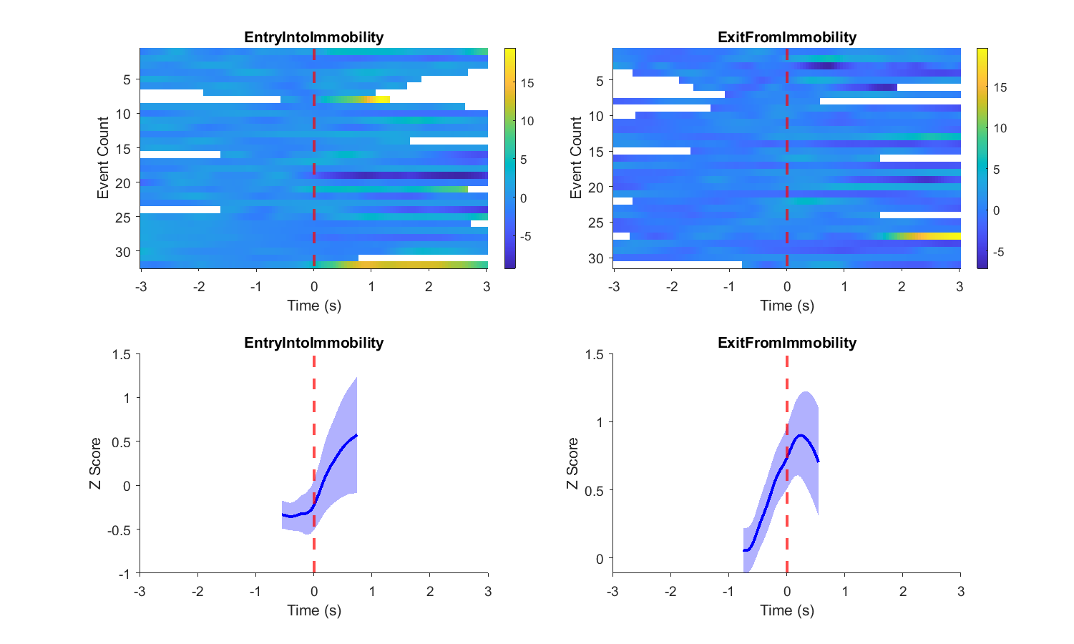

**includeNA- UNCHECKED**

This event plot contains a heatmap plot and mean/sem plot, which plots the “Immobility onset” (i.e., Immobility) data and the “Mobility onset” data (i.e., Mobility) data. In the graph below, “includeNA” was selected. Hence, the mean/sem plot includes peri-event timepoints that contain NaN data, even though the NaN data is not included in the calculation per se. The white space within the heatmap is the location of the NaN data. Each event in the heatmap represents an individual behavioral bout, and the color of the heatmap is the z-score. The color bar indicates the z-score that corresponds to each color.

Another peak plot will also show up as a raster plot of event peaks inside each event episodes, with the line showing the timing of each peak occurred and the color for its amplitude. The binned frequency and amplitude (0.5s) were also summarized in the bottom panels.

As mentioned earlier, the user can update the graphs with new parameters by clicking the “Align Event” button even after finished plotting.



**Data Process Panel**

In this panel, user can 1) lock the file selection panel and Preview Windows to avoid the unintentional change; 2) define the Mouse ID for exporting the data; 3) enable the “manual zScore” to use pre-defined mean and std for calculating the z score of the whole trace, Tese predefined value can be the one calculated from previous analysis.

Lastly, once the user is satisfied with the data analysis, all graphs and data can be exported with the selected signal name and mouse ID included in the filenames. This can be done by locating the “Export All” button in the Data Process Panel in the upper right corner of the application. Pressing this button will do three things:

1. Export all data into an Excel file
2. Export relevant graphs into a single PDF file
3. Export relevant graphs into modifiable .fig files for later manipulation.